AWS Cloud Quest  
**Task 11. Highly Available Web Applications**

Increase website reliability by creating a highly available architecture that spans multiple Availability Zones with load balancing and health monitoring.

|  |  |
| --- | --- |
| Person | Hi! Thank you for answering our request for help. Our travel agency just had a disastrous promotional event. |
| Me | Oh! I’m sorry to hear that. What happened? |
| Person | The promotional even we held last week increased our web traffic and overloaded our web application. All request were being timed out.  Worse than that, our Amazon EC2 Instances were also hosted in an AZ that was affected by severe storms. We were offline for hours. |
| Me | I'm so sorry this happened. Let's talk about how you can prevent it in the future.  First, you can use AWS to create an Auto Scaling group across multiple Availability Zones so that your resources aren't isolated.  Second, you can create a load balancer so that network traffic is distributed equally across your servers. |
| Person | Okay, so if I spread instances out over multiple AZs, will that make us completely safe from failures? |
| Me | Well, no system is 100 percent failure proof, but Availability Zones reside in geographically distinct locations, and a singular event is unlikely to affect multiple AZs simultaneously. |
| Person | Got it. But how can we verify that our application is down in a different AZ? |
| Me | After you spread your EC2 instances over multiple AZs, you can attach an load balancer to your Auto Scaling group for high availability and elasticity.  You can also monitor EC2 instance health by setting up a health check on your load balancer. |
| Person | This sounds promising! Can you build this system for us? Our site needs to handle the increased demand.  Will you help us make our travel booking site highly available? |
| Me | Accepted! |
| Person | Thanks for helping! |

**Learning Objectives**

* Create an auto scaling group across multiple AZs.
* Create a Load Balancer.
* Attach an auto scaling group to a load balancer.
* Create a load balancer health check for EC2 instances.

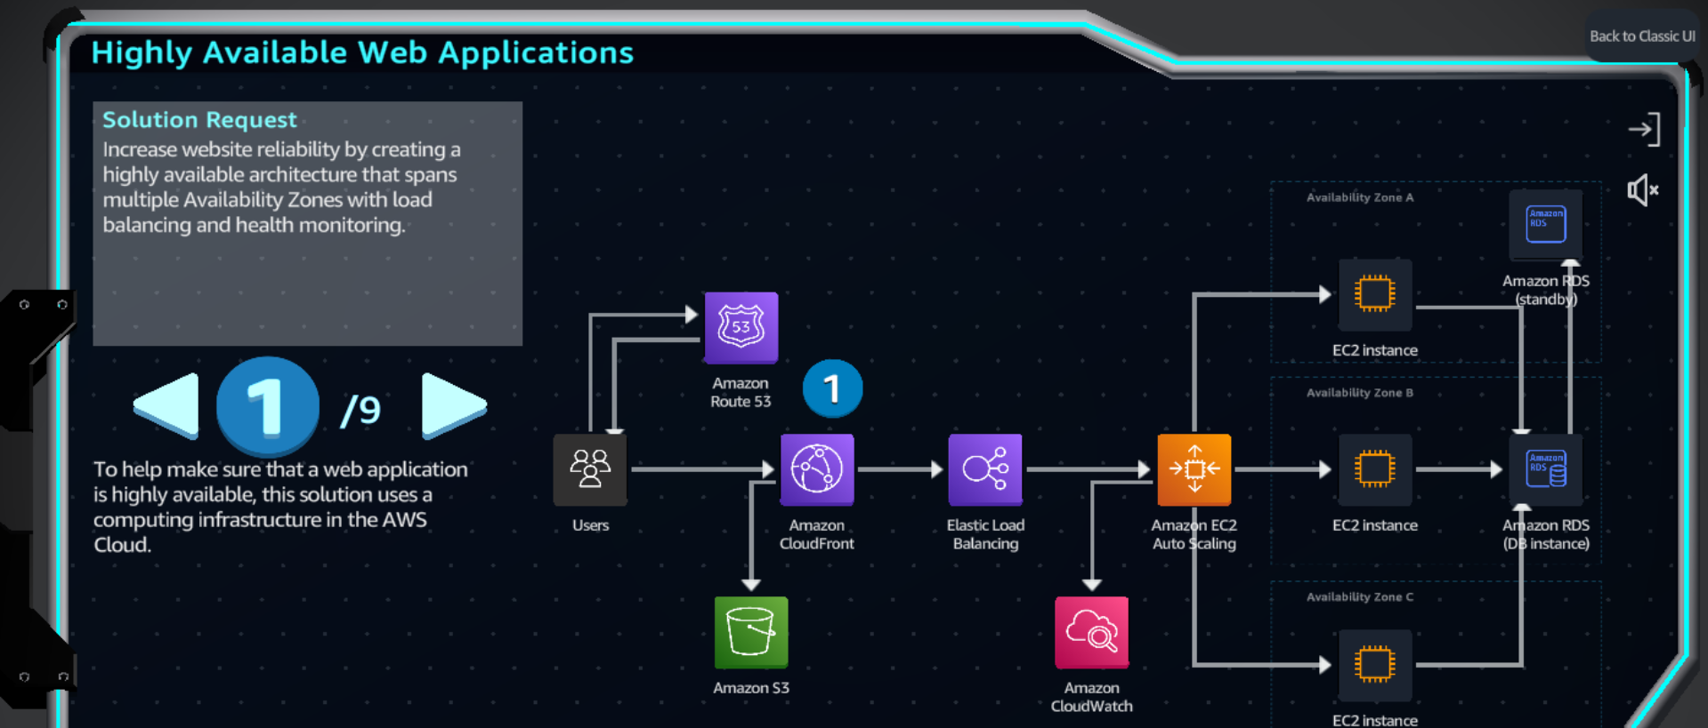

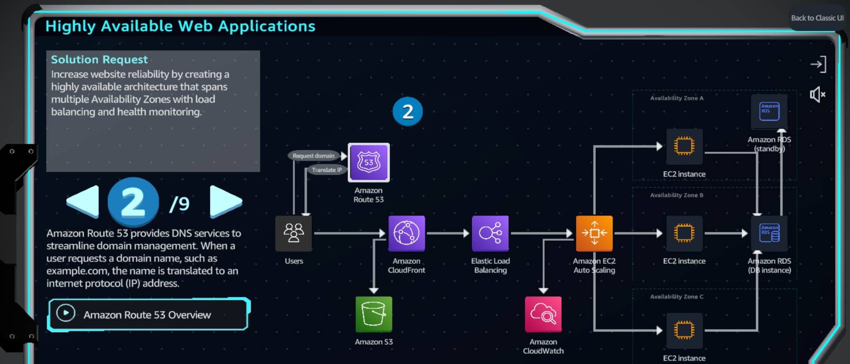

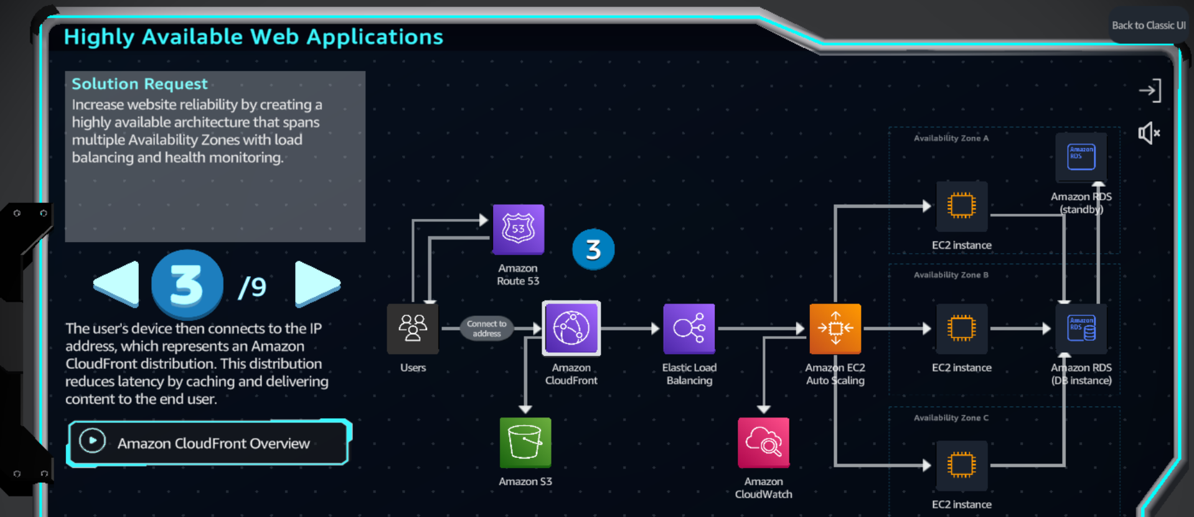 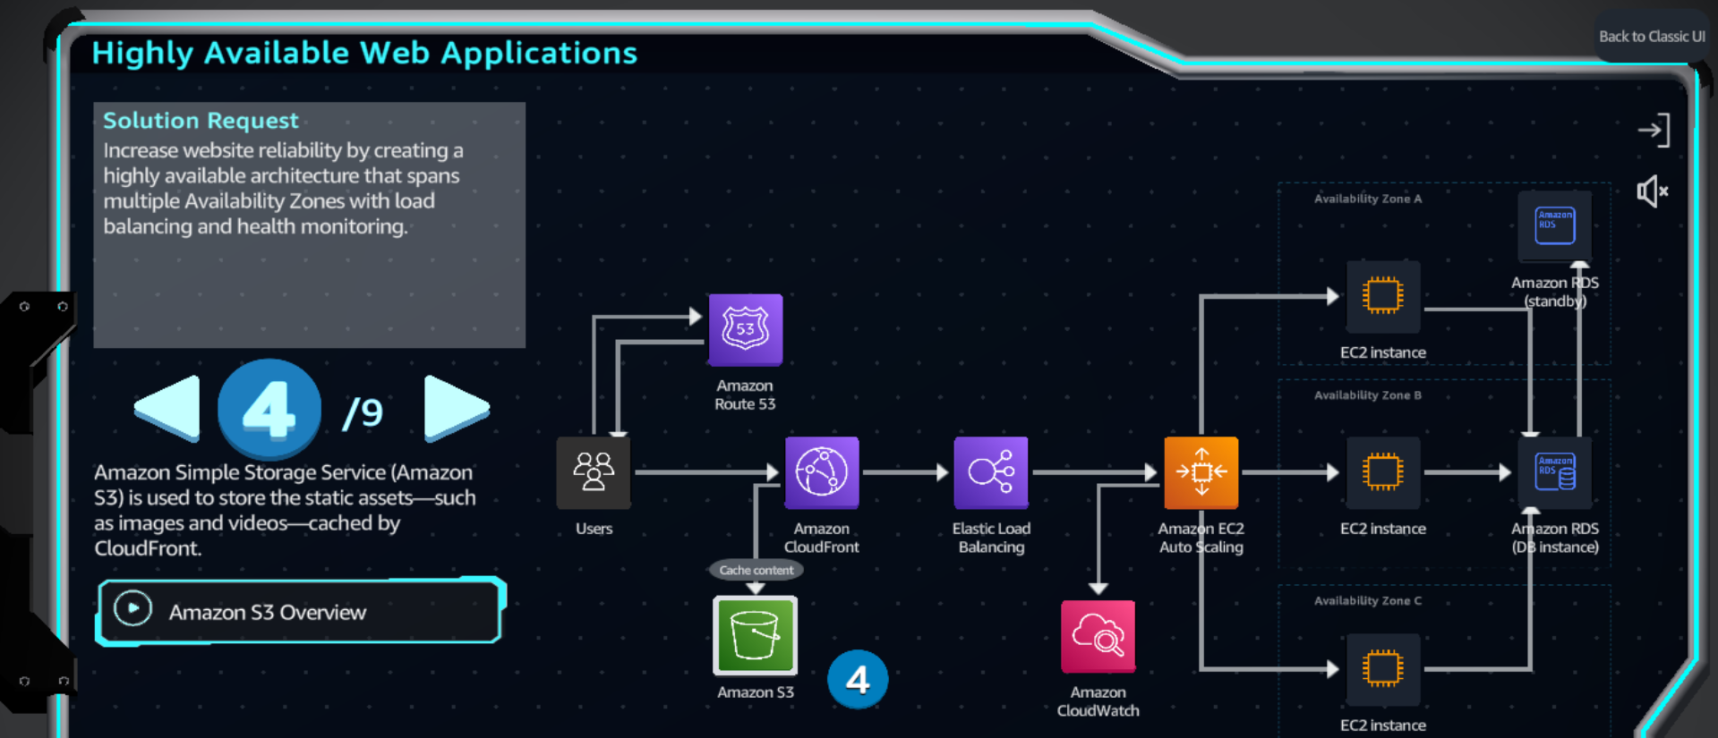 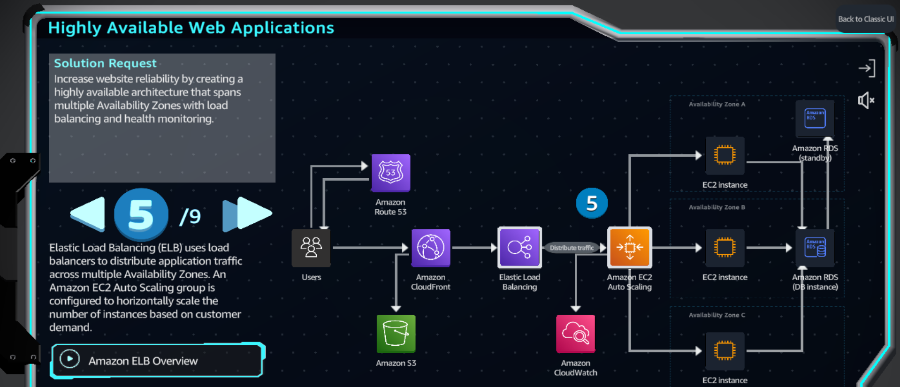

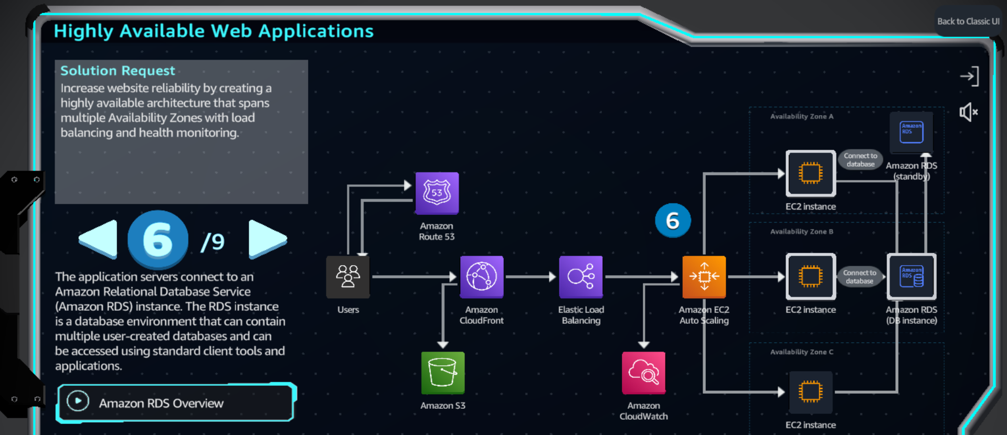 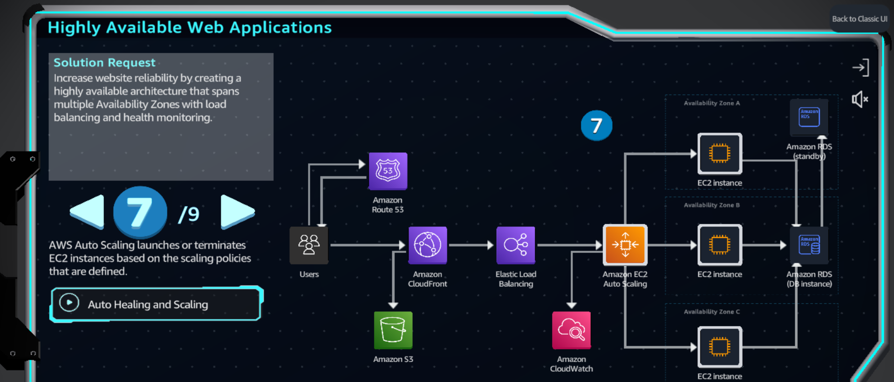 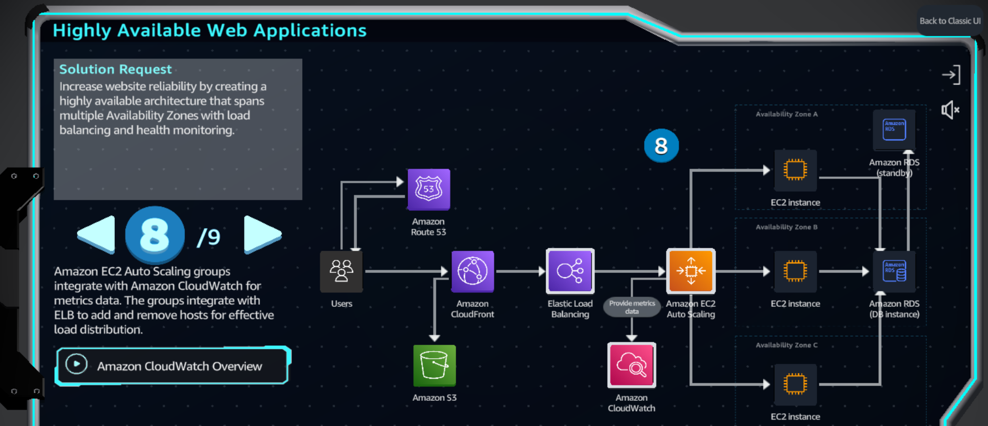

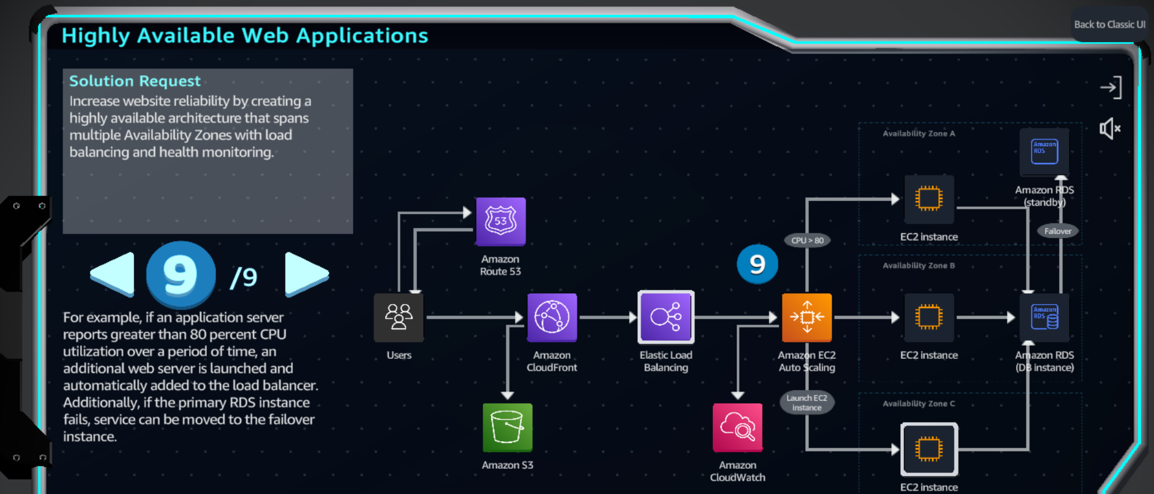

**Practice**

